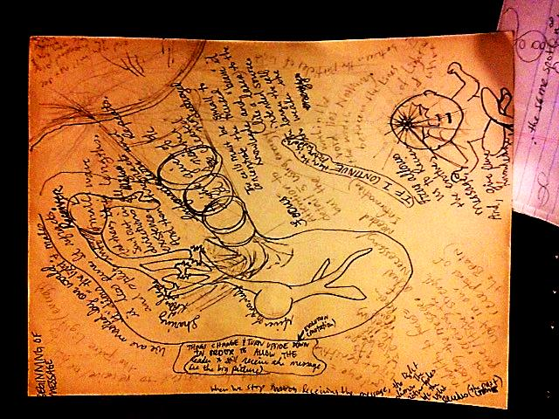

3rd When the transfer is complete, the receiver is exhausted and weak (only if they actually store the message) because so much focus was needed to receive it, no need to truly understand its purpose – just that it was important because it was info seemingly coming from nowhere. Like Right NOW.

PAY ATTENTION TO DETAIL AND ALLOW RECEIPT OF THE PURE MESSAGES. THESE ARE THE MOST IMPORANT BECAUSE IT WAS STORED MOST FREQUENTLY 🡪 to give off more energy of the SAME MESSAGE 🡪 even fragments that overlap and tell the message [remove the “telephone game” bits by rationer) THINKING AND ELIMINATION (LIKE SUDOKU). We sometimes store this info as a human race and rays of this knowledge, light can eventually be interpreted by another receiver, across another space… eventually. TIME EXISTS EVERYWHERE, WITHIN THE SPACE OF EVERYTHING.

You must be very relative in size to be swallowed by a black hole